|  |  |  |  |
| --- | --- | --- | --- |
| Date | Version | Editor | Comments |
| 3//2014 | 1.2 | Ken |  |
| 3/25/2014 | 1.3 | Ken | adding to “new game” section that the Player is only told to make a profile if there isn’t one created already. if they have one already just select it |
| 4/2/2014 | 1.3 | Ken | took out character menu, added a yes or no question to restart mission. |
|  |  |  |  |

**Controls**

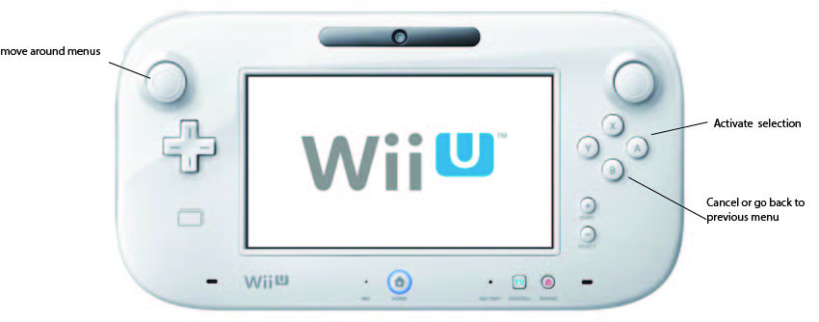

**Splash Screen**

* A image of Ganondorf surrounded by flame, with the title logo and a "press start" prompt superimposed.
* Player is prompted to “Press Start”
* Player does nothing
* Attract Mode cutscene plays
  + returns to Splash Screen if any button is pressed during the Attract Mode cutscene
* Returns to Splash Screen and Player is once again prompted to “Press Start”
* Player presses the start button and goes to the Main Menu

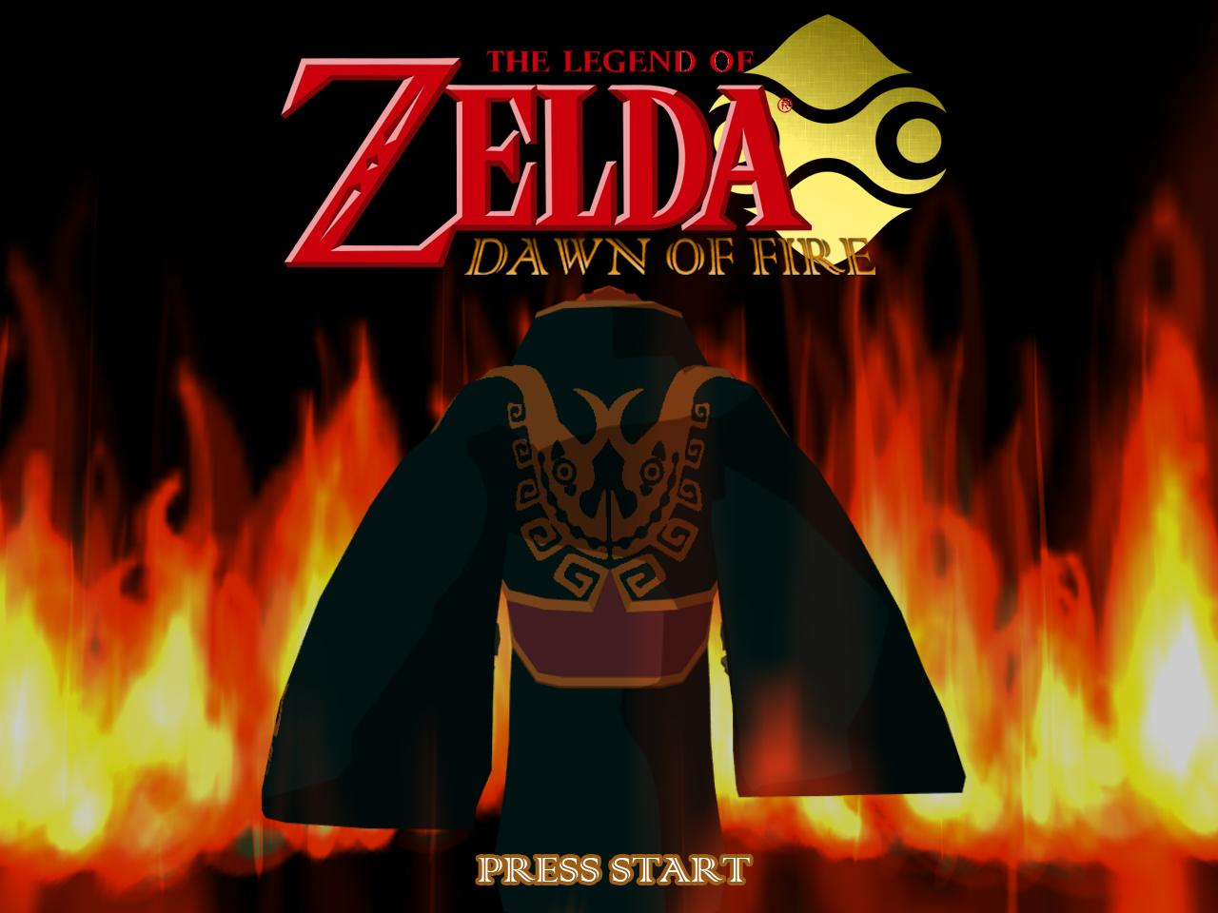

**Main Menu**

* Main Menu comes up with a few options to pick from using the D-pad or left joystick and then press “A” to enter the selected option
  + Continue Game
  + New Game
  + Load Game
  + Settings
* Continue Game
  + Player uses the D-pad or left joystick to move the cursor to select Continue Game
  + Player selects quest log containing data from previous play session
  + if there is no previous play session data, Player is shown a popup message saying “no data found” and is returned to the Main Menu
* New Game
  + Player uses D-pad or left joystick to select profile
  + If the Player has previously created a profile, they will have to select theirs
  + If there is no profile data, then the Player will be told to create a new profile
    - create new profile
    - Profiles contain a Player’s save game files
    - enter profile name: Ganondorf
    - [key board](https://www.google.com/search?q=virtual+keyboard&espv=210&es_sm=93&source=lnms&tbm=isch&sa=X&ei=gUAnU_WsBY-dqwGesoGIDA&ved=0CAoQ_AUoAg&biw=839&bih=689#facrc=_&imgdii=_&imgrc=fXKAf-vr9HnjnM%253A%3BT0RyluRmW0OD9M%3Bhttp%253A%252F%252Fscreenshots.en.sftcdn.net%252Fen%252Fscrn%252F92000%252F92269%252Ffree-virtual-keyboard-4.png%3Bhttp%253A%252F%252Ffree-virtual-keyboard.en.softonic.com%252F%3B700%3B353)

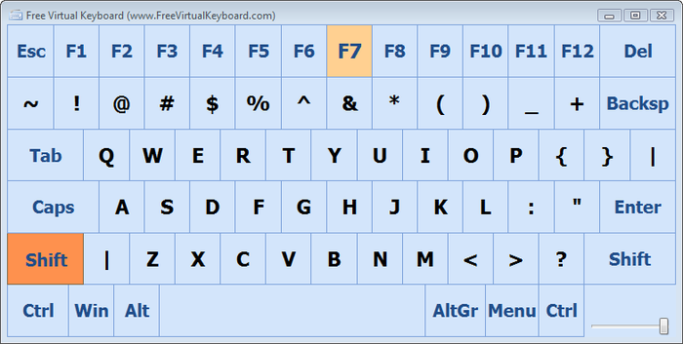

* + Game play loads
  + If the Player does not want to start a new game and wants to return to the Main Menu, they can press “B” to go back to the Main Menu
* Load Game
  + if there is any previous saved game data then the Player can select the quest log slot that holds it by pressing “A”
  + The game data in the selected quest log slot will be loaded and the game will start from the point in the game that the quest log was created from
  + if there is no previous saved game data, then the quest logs will say on them “No Quest log data”
  + the Player can then press “B” to return to the Main Menu
* Settings
  + The Player can use the Left Joystick to select a setting and then press “A” to enter it
    - Sound
      * Contains the adjustable settings for Master Volume, Sound Effects Volume, and Music Volume
        + A slider is used to adjust the volume
    - Controls
      * shows the Player what buttons are used for which actions
      * also shows a few different button set configurations
    - Gamma
      * Allows the Player to adjust the Gamma (Brightness)
        + A slider is used to adjust the volume
  + The Player can exit the Sound, Controls, and Difficulty menus and return to the Settings menu by pressing “B”. and from there can return to the Main Menu by pressing “B” as well

**In Game Pause Menu**

* The menu that comes up when the Player Pauses the game by pressing “Start”, and can select any of the options on the Pause Menu back selecting it with the Left Joystick and pressing “A”
  + Resume Game
    - by selecting this option, the Player will be returned to the game and unpaused
  + Troop Inventory
    - Non-selectable on the Pause Menu on the right hand side of the other options in the Pause Menu
    - Shows the current and maximum number of troops that the Player currently has
      * number of each kind of troop the Player has, and what they loaded with
    - See HUD Funcspec for more info on Unit count display
  + Save
    - Allows the Player to save their current game data in a Quest Log slot
    - Quest Logs show the percentage of the game played through so far, the Total amount of time spent playing, the date and time the game was saved and the Quest Log will have the name of the Profile with the number of the slot used, next to it
    - When the Player selects a Quest Log to save in a prompt will appear asking the Player “Would you like to save your game here?” The Player can choose yes or no
    - If the Player wants to save their game in a Quest Log that has already been saved in previously, a prompt will appear asking the Player “Would you like to Overwrite this save?”
      * This will be asked after the Player is asked if they want to save in that Quest Log or not. choose “Yes” or “No”
  + Load
    - Allows the Player to load previously save game data by selecting a Quest Log slot that contains saved game data
    - When Loading saved game data, progress from their current game play session will be lost
  + Settings
    - Same as the the Setting on the Main Menu except that the Player can only access the Sound, and Controls settings from the Main Menu
  + Restart Mission
    - The Player will be asked “Do you want to restart your current mission? (Progress made during the current mission will be lost)” “Yes” or “No”
    - If the Player chooses “Yes” then the Player will be brought back to the beginning of the mission.
    - If the Player chooses “No” then they will be brought back to the Pause Menu
    - Progress from the Player’s current game play session will be lost
  + Quit
    - Will return the Player to the Main Menu
    - The Player will be asked if they would like to quit, “Yes” or “No”
      * If the Player chooses “Yes” they will be asked if they would like to save first since otherwise progress from current game play session will be lost.
        + A prompt will come up asking if they want to save, “Yes” or “No”
        + If the Player chooses “Yes” then they will be brought to the save menu where they can save their game, and then the game will quit and bring the Player to the Main Menu
        + If the Player chooses “No” then the game will not be saved and the Player will be brought back to the Main Menu
      * If the Player chooses “No” then they will be brought back to the in game Pause Menu